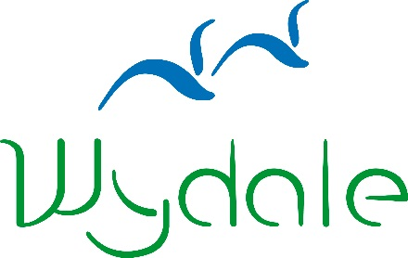

**WYDALE EVENT BOOKING FORM**

|  |  |
| --- | --- |
| **Event Name:** | A Quiet Day in Narnia |
| **Event Date:** | Tuesday 26 May 2020 |

|  |  |
| --- | --- |
| **Name:** |  |
| **Address:** |  |
| **Telephone Number:** |  |
| **Email Address:** |  |
| **Dietary Requirements:** |  |
|  |
| **Booking Reference** | **106007707** |

Please enclose a non-refundable deposit of £10 or the full payment of £25 per person:

Cheques payable to Wydale Hall;   
BACS payments can be made to sort code 404022 Account Number 80883018;

Or call 01723 859270 to make a card payment.

Signed: _______________________________________

Date: _______________________________________

Please send to:

Wydale Hall  
Diocesan Centre  
Brompton by Sawdon  
SCARBOROUGH, YO13 9DG

Tel: 01723 859270

Or email this form to admin@wydale.org

*Please visit our website for booking and cancellation terms and conditions.

www.wydale.org/site/booking-terms

**Cancellation Policy**

Wydale Hall is part of the community of the Diocese of York and we are delighted to be able to offer the facilities that we do. However, as we have food and staffing costs to consider in advance of bookings it can be costly to us if bookings are cancelled or numbers are reduced at the last minute. Therefore we have to draw your attention to our cancellation policy. In exceptional circumstances, we will discuss this with you.

**Please note changes to our cancellation policy (correct at January 2019)  
These cancellation charges apply per person**

25% total cost will be charged for cancellation within 8 weeks of your stay

50% total cost will be charged for cancellation within 4 weeks of your stay

100% total cost will be charged for cancellation within 1 week of your stay

A non-refundable Reservation Fee of the first night’s fee per person for a residential booking and £10 per person for Wydale day events will be required.  
A signed booking form and paid Reservation fee is confirmation of your booking.