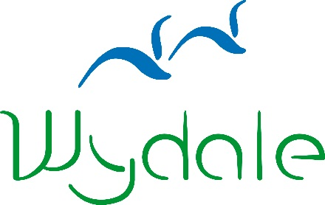

**WYDALE EVENT BOOKING FORM**

|  |  |
| --- | --- |
| **Event Name:** | Owning our Heritage |
| **Event Date:** | 10am-4pm Tuesday 13 April 2021 |

|  |  |
| --- | --- |
| **Name:** |  |
| **Address:** |  |
| **Telephone Number:** |  |
| **Email Address:** |  |
| **Dietary Requirements:** |  |
|  |
| **Booking Reference** | 130885228 |

As a temporary measure, we are not taking payments in advance of Wydale events. However, places on each event are strictly limited so once you have booked, please do let us know if your circumstances change and you are no longer able to attend.

Full cost: £25 per person

Payments are welcome by BACS or by card. Sort code: 404022 A/c: 80883018

Signed: _______________________________________

Date: _______________________________________

Please send to:

Wydale Hall  
Diocesan Centre  
Brompton by Sawdon  
SCARBOROUGH, YO13 9DG

Tel: 01723 859270

Or email this form to admin@wydale.org

*Please visit our website for booking and cancellation terms and conditions.

www.wydale.org/site/booking-terms