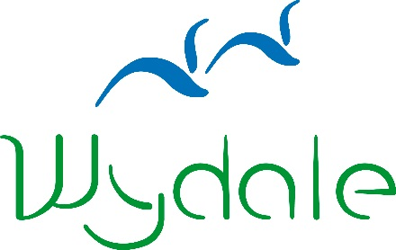

*Please visit our website for booking and cancellation terms and conditions.

www.wydale.org/site/booking-terms

**WYDALE EVENT BOOKING FORM**

|  |  |
| --- | --- |
| **Event Name:** | Responding to a Generous God |
| **Event Date:** | Thursday 9 November 2017 |

|  |  |
| --- | --- |
| **Name:** |  |
| **Address:** |  |
| **Telephone Number:** |  |
| **Email Address:** |  |
| **Dietary Requirements:** |  |
|  |
| **Booking Reference** | **23622** |

Please enclose a non-refundable deposit of £10.00 or the full payment of £25.00 per person

Please make cheques payable to Wydale Hall  
Card payments can be made by telephoning 01723 859270  
Bank payments can be made to sort code 404022 Account Number 80883018

Signed: _______________________________________

Date: _______________________________________

Please send to:

Wydale Hall  
Diocesan Centre  
Brompton by Sawdon  
SCARBOROUGH, YO13 9DG

Tel: 01723 859270

Or email this form to admin@wydale.org

*Please visit our website for booking and cancellation terms and conditions.

www.wydale.org/site/booking-terms