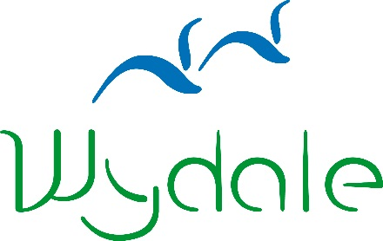

**WYDALE EVENT BOOKING FORM**

|  |  |
| --- | --- |
| **Event Name:** | Working Together 2: Collaborative Projects |
| **Event Date:** | 10 May 2018 |

|  |  |
| --- | --- |
| **Name:** |  |
| **Address:** |  |
| **Telephone Number:** |  |
| **Email Address:** |  |
| **Dietary Requirements:** |  |
|  |
| **Booking Reference** | **29432** |

Please enclose a non-refundable deposit of £10 or the full payment of £25 per person*:

Cheques payable to Wydale Hall;   
BACS payments can be made to sort code 404022 Account Number 80883018;

Or call 01723 859270 to make a card payment.

*\* Contact us about a group rate if booking for more than four people*

Signed: _______________________________________

Date: _______________________________________

Please send to:

Wydale Hall  
Diocesan Centre  
Brompton by Sawdon  
SCARBOROUGH, YO13 9DG

Tel: 01723 859270

Or email this form to admin@wydale.org

*Please visit our website for booking and cancellation terms and conditions.

www.wydale.org/site/booking-terms