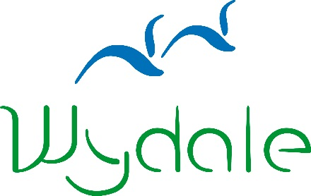
WYDALE EVENT BOOKING FORM

Event Name: | Northern Saints and Anglo-Saxon Roots
Event Date: | Tuesday 21st May 2019

Name:
Address:
Telephone Number:
Email Address:
Dietary Requirements:
Booking Reference | 35480

Please enclose a non-refundable deposit of £10 or the full payment of £25 per person:
Cheques payable to Wydale Hall;
BACS payments can be made to sort code 404022 Account Number 80883018;
Or call 01723 859270 to make a card payment.

Signed: _______________________________________

Date: _______________________________________

Please send to:
Wydale Hall
Diocesan Centre
Brompton by Sawdon
SCARBOROUGH, YO13 9DG
Tel: 01723 859270
Or email this form to admin@wydale.org

*Please visit our website for booking and cancellation terms and conditions.
www.wydale.org/site/booking-terms

Cancellation Policy
Wydale Hall is part of the community of the Diocese of York and we are delighted to be able to offer the facilities that we do. However, as we have food and staffing costs to consider in advance of bookings it can be costly to us if bookings are cancelled or numbers are reduced at the last minute. Therefore we have to draw your attention to our cancellation policy. In exceptional circumstances, we will discuss this with you.

Please note changes to our cancellation policy (correct at January 2018)
These cancellation charges apply per person
25% total cost will be charged for cancellation within 8 weeks of your stay
50% total cost will be charged for cancellation within 4 weeks of your stay
100% total cost will be charged for cancellation within 1 week of your stay
A non-refundable Reservation Fee of 20% per person for a residential booking and £10 per person for Wydale day events will be required.
A signed booking form and paid Reservation fee is confirmation of your booking.

